Assignment No 5

Name Muhammad Ali

Sid 9363

Cid 102326

Design a Bus network which consist of four router use the network address which have been assigned in a lab session apply summary route on this network

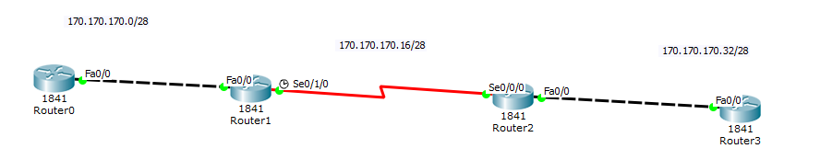

**Router 0**



**Router 1**



**Router 2**



**Router 3**

